

Draw It of Lose It

# **CS 230 Project Software Design Template**

Version 1.0

## Table of Contents

**CS 230 Project Software Design Template**1

**Table of Contents**2

**Document Revision History**2

**Executive Summary**3

**Design Constraints**3

**System Architecture View**3

**Domain Model**3

**Evaluation**3

**Recommendations**5

## Document Revision History

| Version | Date | Author | Comments |
| --- | --- | --- | --- |
| 1.0 | 05/18/21 | Jonathan Sussan | Executive summary and design constraints. |
| 1.1 | 06/05/21 | Jonathan Sussan | Evaluation and recommendations. |

**Instructions**

Fill in all bracketed information on page one (the cover page), in the Document Revision History table, and below each header. Under each header, remove the bracketed prompt and write your own paragraph response covering the indicated information.

## Executive Summary

The Gaming Room wants to develop a web-based game that serves multiple platforms based on their current game called “Draw It of Lose It”. The game is currently only available as an Android App. The App should be available on all platforms.

## Design Constraints

* Decide on a schedule and budget for the project.
* Theme, functions, fonts, colors, and layout should be like existing *Draw It of Lose It* game that is on Android.
* Interface should be user-friendly and easy to navigate no matter which platform you are using to play the game.
* One instance of the game can exist in memory at any given time.
* Every team and player must have a unique name.

## System Architecture View

Please note: There is nothing required here for these projects, but this section serves as a reminder that describing the system and subsystem architecture present in the application, including physical components or tiers, may be required for other projects. A logical topology of the communication and storage aspects is also necessary to understand the overall architecture and should be provided.

## Domain Model

**Entity** has a relationship with **Game**, **Team**, and **Player** classes as the 3 classes extend **Entity**. The 3 classes **Game**, **Team**, and **Player** are all inherited from **Entity** which is represented in the UML diagram as inheritance. The 3 classes **Game**, **Team**, and **Player** have common attributes such as **id** and **name**. This is defined **Entity** as a Super class.

The UML diagram below show that **Team** and **Player** have a relationship. **Game** has a relationship with **Teams** and **GameService**. This is shown by Aggregation. Has a relationship means that an instance of one class has a reference to an instance of another class. **GameService** can have multiple **Games**, each **Game** can have multiple **Teams**, and **Teams** contain **Players**.

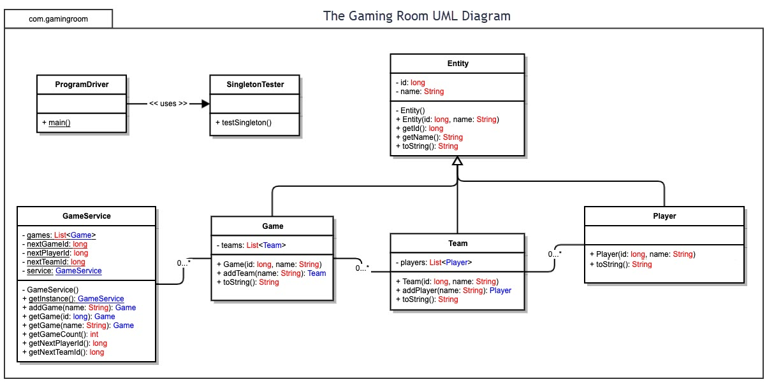

## Evaluation

Using your experience to evaluate the characteristics, advantages, and weaknesses of each operating platform (Linux, Mac, and Windows) as well as mobile devices, consider the requirements outlined below and articulate your findings for each. As you complete the table, keep in mind your client’s requirements and look at the situation holistically, as it all has to work together.

In each cell, remove the bracketed prompt and write your own paragraph response covering the indicated information.

| **Development Requirements** | **Mac** | **Linux** | **Windows** | **Mobile Devices** |
| --- | --- | --- | --- | --- |
| **Server Side** | **Pro**: Standard operating system that can run Java and Web Server environment.  **Pro**: Mac has simple accessibility and server configuration.  **Pro**: Simple and clean graphical user interface offering ease of use.  **Pro**: Many bench-marking tools available to test server performance under high load.  **Con**: Expensive system to run server on.  **Con**: May require time and training to learn how to navigate. | **Pro**: Standard operating system that can run Java and Web Server environment.  **Pro**: Patch management is much easier as typically one command or wizard must be invoked to update everything.  **Pro**: Inexpensive system to run server on.  **Pro**: Free open-source library.  **Pro**: Many bench-marking tools available to test server performance under high load.  **Con**: Requires more time and effort to manage.  **Con**: With so many options, it requires time and training on figuring things out.  **Con**: Difficult to navigate the platform. | **Pro**: Standard operating system that can run Java and Web Server environment.  **Pro**: Most developers are proficient with this operating system.  **Pro**: User friendly GUI.  **Pro**: Lots of software options for developers. Command prompt.  **Pro**: Windows dedicated support.  **Pro**: Many bench-marking tools available to test server performance under high load.  **Con**: Must get OS patches from Microsoft and 3rd party patches from each individual vendor.  **Con**: Windows server side is expensive. | **Pro**: Can use a lightweight API to request only the range needed from server.  **Con**: Need to access external services using APIs.  **Con**: Since API work on top of HTTP, it is important to ensure proper web service security is implemented to avoid unauthorized access, snooping, and DDoS attacks.  **Con**: Having too many client requests in place could make server load high which results in poor performance.  **Con**: Wireless connectivity only; no high-speed ethernet connectivity. |
| **Client Side** | **Pro**: Can use Safari, Google Chrome, Firefox, Brave & Opera browsers.  **Pro**: More secure than Windows due to its UNIX base.  **Pro**: Almost no spyware or virus applications.  **Con**: Gaming performance is lower than other OS due to hardware limitations.  **Con**: More expensive upfront.  **Con**: More complex due to its UNIX base.  **Con**: Less support as you must go to Apple for all hardware problems. | **Pro**: Can use Google Chrome, Firefox, & Opera browsers.  **Pro**: More secure than other OS options.  **Con**: Geared more towards professionals and enthusiasts due to its powerful features and flexibility.  **Con**: The latest and greatest hardware is typically slower to reach Linux.  **Con**: Is not really tailored for gaming.  **Con**: Limited support.  **Con**: Incompatible with Safari browser. | **Pro**: Most widely used OS for gaming applications.  **Pro**: Can use Edge, Google Chrome, Firefox, Brave & Opera browsers.  **Pro**: Most widely supported operating system for games.  **Pro**: More than 80% of desktop computers run Windows.  **Con**: Most prone to spyware and virus applications.  **Con**: General instability due to shear number of possible configurations.  **Con**: Apple no longer develops Safari for Windows. | **Pro**: Provides greater accessibility to gaming due to convenience.  **Pro**: Low cost as generally most people own a smart phone.  **Pro**: Android users can use the same browsers found in Windows and Linux OS.  **Pro**: IOS users can use the same browsers found in Mac OS.  **Con**: Game is played on a smaller screen which may affect user experience.  **Con**: Game performance may suffer due to hardware limitations or network latency. |
| **Development Tools** | **Pro**: Support for Java Server and Web front end.  **Pro**: Intuitive, simple, and clean user interface.  **Pro**: Easily install packages, development tools, and apps.  **Pro**: Great at multitasking which lets developers run multiple tools at once.  **Pro**: Apple offers many options for tech support.  **Con**: Equipment to run development tools is expensive.  **Con**: Inflexible upgrades if the need for more RAM or other upgrades are needed. | **Pro**: Support for Java Server and Web front end.  **Pro**: Android smart phones work on Linux-based kernel.  **Pro**: Reliable to use as no need to worry about updates stopping you from working.  **Pro**: Security, as you can encrypt your drive and offers network security.  **Pro**: Fast, efficient, and lightweight so programming and scripting run faster.  **Pro**: Equipment to run development tools is cost friendly.  **Con**: Because it is free, not enough people are working on debugging the system.  **Con**: Unsupported software.  **Con**: No tech support. | **Pro**: Support for Java Server and Web front end.  **Pro**: Equipment to run development tools is cost friendly.  **Pro**: Lots of supported software.  **Pro**: Upgrades such as RAM are easy to achieve if needed.  **Pro**: Most developers are proficient with this operating system.  **Con**: Drivers, trying to get a variety of components to work together can cause problems.  **Con**: Forced updates can cause unexpected problems. | **Pro**: Development happens on desktop machines and then deployed to mobile platform.  **Con**: Development does not happen on mobile platforms.  **Con**: Requires mobile specific development toolkit. |

## Recommendations

Analyze the characteristics of and techniques specific to various systems architectures and make a recommendation to The Gaming Room. Specifically, address the following:

1. **Operating Platform**: Windows server operating system is recommended for expansion and best results. Windows server bridges on-premises environments with Azure, adding additional layers of security. With a protected and supervisor mode, Windows server OS ensures computer reliability. This helps to serve the client their specific requests of computer running on that network. This feature ensures optimal performance from the computers and users. Windows server OS supports many different server roles including web server, file server, application server, database server, mail server, print server, etc. Windows server OS is designed specifically to run on server hardware.
2. **Operating Systems Architectures**: Windows server OS architectures encompass a variety of concepts including file and memory management. This allows the user to control and optimize the computer’s memory. For example, allocating bits of memory to different programs and free the space when it is no longer being used. By utilizing multi-processor configuration, Windows server provides optimal application performance on computers with multi-processors. Multi-processor scheduling assigns a percentage of the processor’s power to tasks from a ready state to a running state of process. Command prompt PowerShell configuration allows for quick and easy regular server maintenance and configuration across a company’s computers. Windows OS also provides developers the option to work with a vast array of programming languages.
3. **Storage Management**: Windows server OS allows for a routine relocation of blocks of information to solid state storage to free additional storage for the user. This ensures that the computers have plenty of storage space needed to modify and save data without running out of storage. Users can also read/write company files on both personal and work devices through copying to servers in the data center.
4. **Memory Management**: Memory management options with Windows server OS contain random access memory, physical and virtual address space allowing between 2 to 4 gigabytes of memory. Supported page file enables the system to move pages of virtual address spaces to the system hard drive. This helps to free the random-access memory frame for additional needs or uses.
5. **Distributed Systems and Networks**: Using network support in distributed systems is an efficient method to implement and utilize software for those systems. The feature of distributed systems and networks offers simple communication with each other and various processors between many workstations. Another useful feature is the user’s ability to communicate with different servers like web servers, data servers, etc. Computers on the same network run efficiently as tasks are divided up and processed among both the user and server.
6. **Security**: We will need to employ the *Principle of Least Privilege* to avoid potential security issues due to mishandling of access rights. Windows’ provided security layers help to prevent breaches in data or sensitive information. This feature blocks harmful attacks while improving overall security. Windows server OS also feature shielded virtual machines. With virtual machines, unauthorized access to protected data is prevented by host administrators. The Windows Defender Application Control ensures the control of which applications can run on the computer. This feature does not require additional hardware or software to run. Windows server OS users have built-in protection against memory corruption attacks. The advanced threat analytics feature uses an active directory for network traffic as well as SIEM data to locate and notify the user of potential threats. Windows also features BitLocker Drive Encryption which secures the operating system booting process and prevents unauthorized data mining. BitLocker works even when the server is not powered on and is an effective anti-hacking tool against malware hacking.